Assessment Schedule – 2012

Physics: Demonstrate understanding of aspects of wave behaviour (90938)

Assessment Criteria
Correct significant figures are not required and units are required only in the questions that specifically ask for them.

Question |  | Achievement |  |  | Merit |  |  |  | Excellence
ONE  (a) |  | Correct drawing including normal  OR  Correct labelling of angles |  |  | 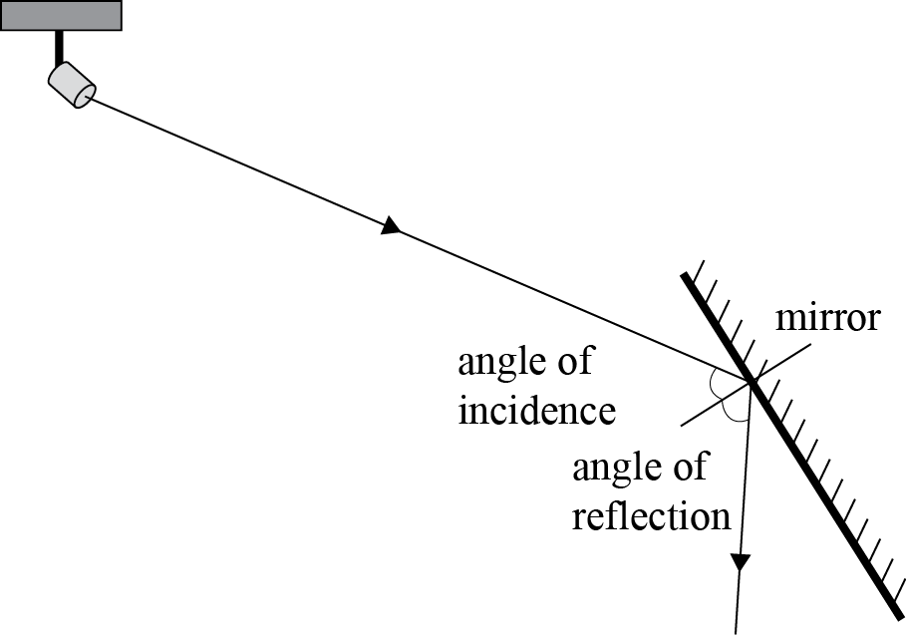  Correct drawing including normal.  AND  Correct labelling of angles.
(b) |  | States they are equal. |  |  | States they are equal.  AND  Explains using the Law of Reflection (extra information such as “parallel” is neutral).  OR  Mirror is smooth / flat (extra information such as “parallel” negates the answer).  OR  Correct Geometrical reasoning, eg the angle of incidence + angle of incident ray to mirror = 90° and the angle of reflection + angle of reflected ray to mirror = 90° AND  i = r, so angle of incident ray to mirror = angle of reflected ray to mirror
(c)(i) and (ii) |  | (i) X is drawn correctly  OR  (ii) ONE ray is drawn correctly including dotted line for virtual ray and arrows and X as point of origin for virtual ray.  (Allow virtual rays from top / bottom of girl’s image as opposed to X.) |  |  | (i) X is drawn correctly  AND  (ii) ONE ray is drawn correctly including dotted line for virtual ray and arrows and X as point of origin for virtual ray.  (Allow virtual rays from top / bottom of girl’s image as opposed to X.) |  |  |  | (i) X is drawn correctly  AND  (ii) BOTH rays are drawn correctly including dotted lines for virtual rays and arrows and X as point of origin for virtual ray.  (Allow virtual rays from top and bottom of girl’s image as opposed to X.)  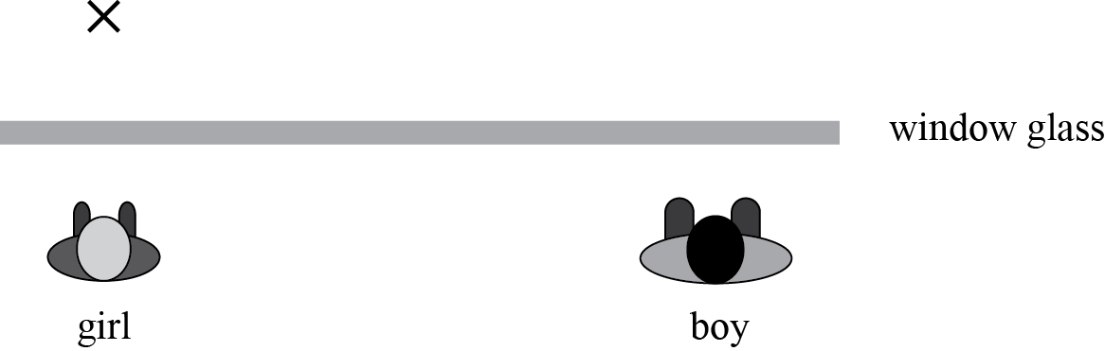  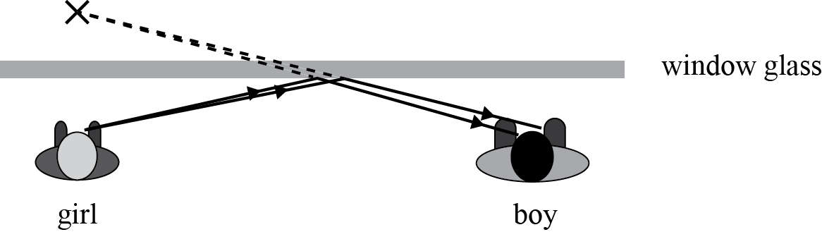
(d)(i) |  | EITHER of the incident rays are drawn correctly including arrows. |  |  | EITHER of the rays are fully drawn correctly, including arrows and dotted lines. |  |  |  | 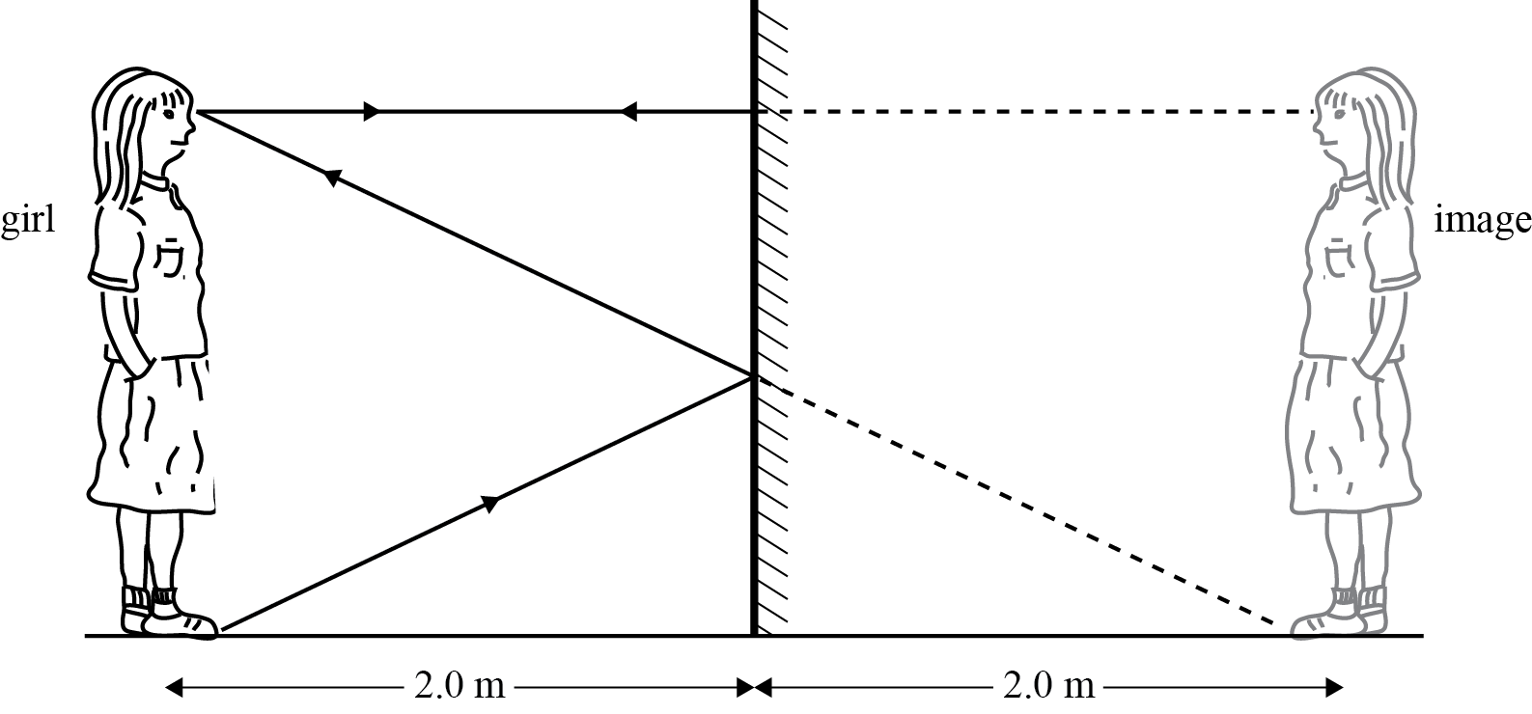  BOTH of the rays are fully drawn correctly including arrows and dotted lines
((ii) |  |  |  |  | The explanation that:  The top of the mirror needs to be just above eye level to be able to see her head.  OR  The light from her feet is reflected off the mirror at the midpoint between the floor and the eye level to be able to see her feet is supported by the ray diagram (although this may not be complete). |  |  |  | The explanation that:  The top of the mirror needs to be just above eye level to be able to see her head.  AND  The light from her feet is reflected off the mirror at the midpoint between the floor and the eye level to be able to see her feet is supported by the ray diagram (although this may not be complete).
NØ | N1 |  | N2 | A3 |  | A4 | M5 | M6 |  | E7 | E8
No evidence | 1a |  | 2a | 3a |  | 4a | 2m | 3m |  | 2e | 3e

Question |  | Achievement |  |  | Merit |  |  |  | Excellence
TWO  (a)(i)  (ii) |  | Transverse / electromagnetic wave (or suitable alternative)  AND  Longitudinal/sound (or suitable alternative) wave.
(b) |  | Space communications use electromagnetic waves / transverse waves / Wave A.  OR  Space communications do not use sound / longitudinal waves / Wave B. |  |  | Space communications use electromagnetic waves / transverse waves / Wave A. They do not require a medium to travel.  OR  Space communications do not use sound / longitudinal waves / Wave B. They require a medium to travel (and space has no medium / space is empty).
(c) |  | Frequency affects pitch OR The pitch decreases  (but “frequency decreases means increase in pitch” is incorrect)  AND  Amplitude affects loudness OR Loudness increases  (but “increased amplitude means decreased loudness” is incorrect) |  |  | Clearly links (cannot be inferred):  Frequency to pitch AND states the pitch decreases (by exactly what proportion is not marked) because it depends on the frequency.  OR  Clearly links (cannot be inferred):  Amplitude to loudness AND states that loudness increases (by exactly what proportion is not marked) because loudness depends on amplitude. |  |  |  | Clearly links (cannot be inferred):  Frequency to pitch AND states the pitch decreases (by exactly what proportion is not marked) because it depends on the frequency.  AND  Clearly links (cannot be inferred):  Amplitude to loudness AND states that loudness increases (by exactly what proportion is not marked) because loudness depends on amplitude.
(d)(i) |  |  |  |  |  |  |  |  | A pulse is a single disturbance / crest / trough that moves through a medium from one point to the next point.  OR  A pulse transfers a small amount of energy from one point to the next point in the medium.
(ii) |  | Calculates the speed of the wave in the cable as  = 0.60 × 3.0 × 10⁸  = 1.8 × 10⁸ m s^{–1}  OR  Uses 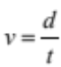 incorrectly to calculate the up and down distance travelled by the pulse Eg:  using incorrect value for v as  3 × 10⁸, to completion  (eg 690 m)  using incorrect value for v as  1.8 × 10^{–8}, to completion  using incorrect value for t as  2.3 × 10⁺⁶ to completion. |  |  | Calculates the speed of the wave in the cable as  = 0.60 × 3.0 × 10⁸  = 1.8 × 10⁸ m s^{–1}  AND  Uses correctly using  1.8 × 10⁸ to calculate the up and down distance travelled by the pulse to completion but gets incorrect answer (eg 414 m). |  |  |  | Calculates the speed of the wave in the cable as  = 0.60 × 3.0 × 10⁸  = 1.8 × 10⁸ m s^{–1}  AND  Uses correctly using  1.8 × 10⁸ to calculate the up and down distance travelled by the pulse to completion  = 2.3 × 10^{–6} × 1.8 × 10⁸ = 414 m  AND  Realises that the echo is the up and down distance so divides by 2, ie  The fault is 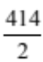 = 207 m away.
NØ | N1 |  | N2 | A3 |  | A4 | M5 | M6 |  | E7 | E8
No evidence | 1a |  | 2a | 3a |  | 4a | 2m | 3m |  | 2e | 3e

Question |  | Achievement |  |  | Merit |  |  |  | Excellence
THREE  (a)(i)  (ii) |  | Diffraction is the bending of waves round an obstacle / through a (small) gap. |  |  | Diffraction is the bending of waves round an obstacle / through a small gap.  AND  Yes |  |  |  | Diffraction is the bending of waves round an obstacle / through a small gap.  AND  (Yes)  Longer wavelength diffract more than shorter ones (but if talking about diffraction through a gap then the gap must approximately equal the wavelength).
(b) |  | The sketch shows the correct shape (straight wave fronts for part of wave moving straight on without being diffracted AND curved wave fronts behind the peninsula), but the wave length changes.  OR  The sketch shows the wavelength staying the same but with wrong shape. |  |  | The sketch shows the correct shape (straight wave fronts for part of wave moving straight on without being diffracted AND curved wave fronts behind the peninsula) with no change in wavelength, but the diffraction does not occur in line with the edge of the peninsula. |  |  |  | 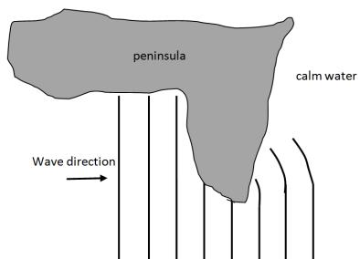  The sketch shows the correct shape (straight wave fronts for part of wave moving straight on without being diffracted AND curved wave fronts behind the peninsula) with no change in wavelength.  AND  The diffraction occurs in line with the edge of the peninsula.
(c) |  | Calculates the frequency correctly.  Frequency, f = 0.67 Hz  But incorrect calculation of v from f.  OR  Incorrectly calculates value of f, but calculates v correctly from incorrect value of f.  v = f × λ = 0.67 × 0.85  = 0.57 m s^{–1}  (unit not required) |  |  | Calculates the frequency correctly.  Frequency, f = 0.67 Hz  AND  correctly calculates v  v = f × λ = 0.67 × 0.85  = 0.57 m s^{–1}  (unit not required)
(d)(i) |  | (Time) Period  OR  Calculates the wavelength correctly.  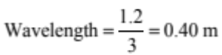  (Be careful because  0.64 / 1.2 = 0.53. which is entirely wrong.) |  |  | (Time) Period  AND  Calculates the wavelength and frequency correctly.  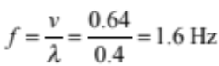  OR  Calculates the wavelength and frequency correctly.  AND  Calculates the Time Period correctly.  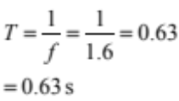 |  |  |  | (Time) Period  AND  Calculates the wavelength and frequency correctly.  AND  Calculates the Time Period correctly.
NØ | N1 |  | N2 | A3 |  | A4 | M5 | M6 |  | E7 | E8
No evidence | 1a |  | 2a | 3a |  | 4a | 2m | 3m |  | 2e | 3e

Question |  | Achievement |  |  | Merit |  |  |  | Excellence
FOUR  (a) |  | Light slows down entering the plastic.  OR  Light speeds up as it leaves the plastic. |  |  | Light slows down entering the plastic.  AND  Light speeds up as it leaves the plastic.
(b)(i)  (ii) |  | The optical density of medium A is greater than that of medium B.  OR  The angle of incidence is equal to the critical angle |  |  | The optical density of medium A is greater than that of medium B.  AND  The angle of incidence is equal to the critical angle.
(c) |  | Correct Total Internal Reflection at B.  OR  Correct bending of rays at A and C. |  |  | Correct Total Internal Reflection at B including correct drawing of normal  AND  Correct bending of rays at A and C including correct drawing of normal. |  |  |  | 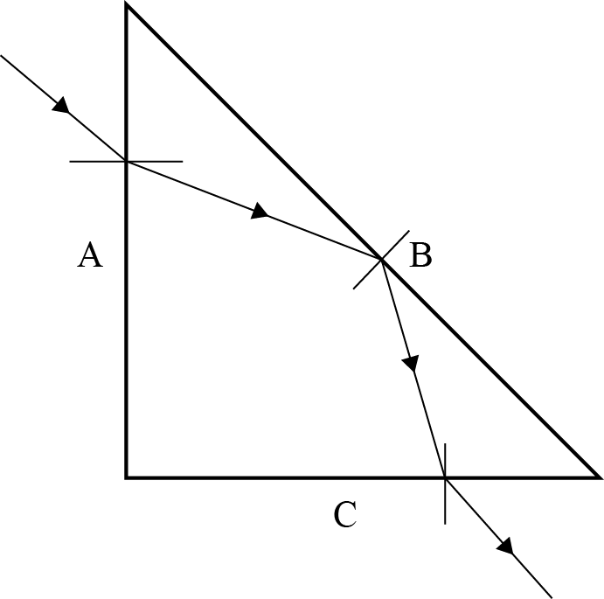  Correct Total Internal Reflection at B including correct drawing of normal.  AND  Correct bending of rays at A and C including correct drawing of normal.  AND  Incident ray to prism and emergent ray are parallel to each other.
(d)(i)  (ii) |  | ONE of the rays is drawn correctly (arrows not required). |  |  | Correct ray diagram including clear identification of two rays of light by one / two arrows (or different pen colour). |  |  |  | Correct ray diagram including one / two arrows (or different pen colour).  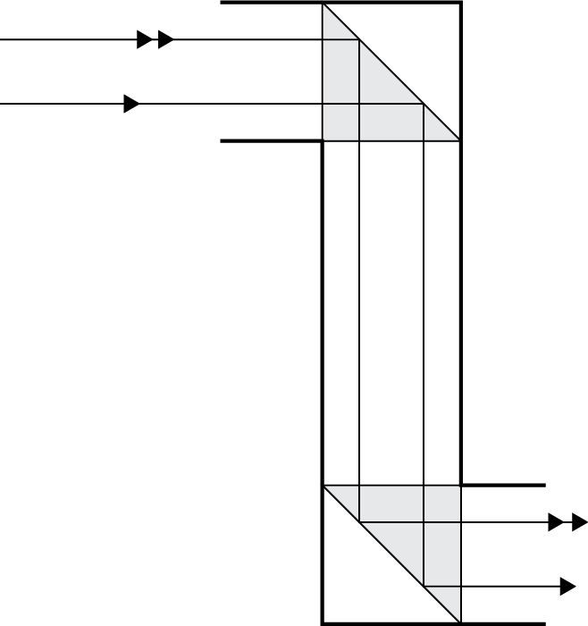  AND  Upright, because the relative positions of the rays remain the same before and after the reflection / laterally inverted twice.
(iii) |  | The rays enter and leave the prisms at right angles / perpendicular to the faces of the prism. |  |  | The rays enter and leave the prisms at right angles / perpendicular to the faces of the prism.  AND  No refraction / bending of rays takes place. |  |  |  | The rays enter and leave the prisms at right a angles / perpendicular to the faces of the prism.  AND  No refraction / bending of rays takes place.  AND  It is the refraction / bending of light that causes dispersion of different colours.
NØ | N1 |  | N2 | A3 |  | A4 | M5 | M6 |  | E7 | E8
No evidence | 1a |  | 2a | 3a |  | 4a | 2m | 3m |  | 2e | 3e

Judgement Statement

 | Not Achieved | Achievement | Achievement  with Merit | Achievement  with Excellence
Score range | 0 – 9 | 10 – 18 | 19 – 25 | 26 – 32

